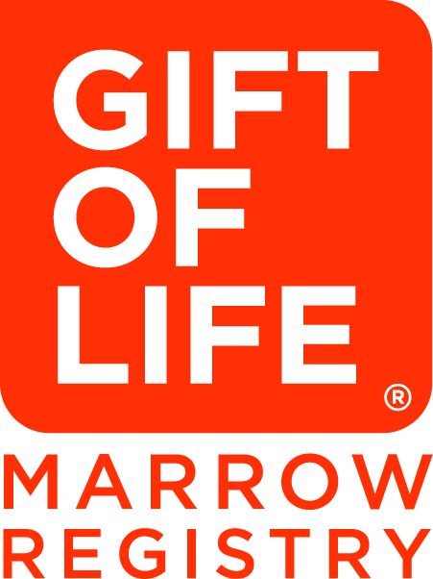

**-FOR IMMEDIATE RELEASE-**

Media contact: **Edwige Buteau**, Gift of Life Marrow Registry

Office: +1 (516) 982-2921; Cell: +1 (917) 655-3843; ebuteau@giftoflife.org

|  |
| --- |
|  |

**GIFT OF LIFE MARROW REGISTRY, RUTGERS AND ROOT RESEARCHERS LAUNCH CROWD STUDY OF TISSUE MATCH GENES IN COVID-19**

**Gift of Life members can help understand how immune-vital genes shape the pandemic**

**Link to study: giftoflife.org/public/covid19surveyrequest**

**Boca Raton, FL, June 29 –** Human leukocyte antigens (HLA) – diverse genetic markers on our cells that help match patients and donors for bone marrow transplant – are the focus of a [new study](https://www.giftoflife.org/public/covid19surveyrequest) led by the Gift of Life Marrow Registry.

The study, in collaboration with researchers at Rutgers Cancer Institute of New Jersey and the genetic crowd science portal Root, aims to help answer a key question: why do some people get COVID19 or particular symptoms, while others avoid them? More than 350,000 donors in Gift of Life’s registry have been invited to participate, helping researchers answer this important question.

“Every volunteer donor is already *HLA*-typed, presenting a tremendous opportunity to drive broader science through the prism of these immune-related genes,” said Gift of Life’s Founder and CEO [Jay Feinberg](https://en.wikipedia.org/wiki/Jay_Feinberg). “We’re excited to help the world understand how our immune systems may shape the pandemic.”

“We hope to learn whether immune-vital tissue match genes such as *HLA* help explain why some of us avoid COVID-19, while others get severe symptoms or need particular treatments,” said the study’s principal investigator [Jeffrey Rosenfeld, PhD](https://www.cinj.org/researcher-profiles?path=results&last=Rosenfeld&first=Jeffrey&faculty_research=)**,** Assistant Professor of Pathology and Laboratory Medicine, Rutgers Robert Wood Johnson Medical School. “Adding such key data to the fight against COVID-19, we can help solve the mystery of why it affects different people so differently.”

Root's founder, geneticist [Nathaniel Pearson, PhD](https://www.youtube.com/watch?v=NxkL-KtUaJY), noted that “because transplant registries read *HLA* genes better than consumer DNA tests do, a study like this can best reveal how these diverse, immune-vital genes may shape COVID-19. Gift of Life members, who have long saved lives via transplants, now show us how everyday people can help the world beat a pandemic too.”

Participants can also opt into short monthly surveys for the coming year, even if they have never had COVID-19. The researchers will study their de-identified data, to better understand how tissue match genes and other factors may figure in COVID-19 risks and outcomes.

The new study furthers Gift of Life's efforts to help people and communities in need during the pandemic. The organization has increased capacity at the Dr. Miriam and Sheldon G. Adelson Gift of Life–Be The Match Collection Center to become a non-hospital based go-to for stem cell donations and contributed 10,000 specialized swabs to Baptist Health South Florida via Boca Raton Regional Hospital to be used for COVID-19 testing.

**About Gift of Life Marrow Registry**

The Gift of Life Marrow Registry is a 501(c)(3) nonprofit organization headquartered in Boca Raton, Fla. The organization, established in 1991, is dedicated to saving lives by facilitating bone marrow and blood stem cell transplants for patients with leukemia, lymphoma, and other blood-related diseases. To learn more about Gift of Life or to make a tax-deductible donation, visit [www.giftoflife.org](http://www.giftoflife.org).

**About Rutgers Cancer Institute of New Jersey**

As New Jersey’s only National Cancer Institute-designated Comprehensive Cancer Center, Rutgers Cancer Institute, along with its partner RWJBarnabas Health, offers the most advanced cancer treatment options including bone marrow transplantation, proton therapy, CAR T-cell therapy and complex robotic surgery. Along with clinical trials and novel therapeutics such as precision medicine and immunotherapy – many of which are not widely available – patients have access to these cutting-edge therapies at Rutgers Cancer Institute of New Jersey in New Brunswick, Rutgers Cancer Institute of New Jersey at University Hospital in Newark, as well as through RWJBarnabas Health facilities.

Along with world-class treatment, which is often fueled by on-site research conducted in Rutgers Cancer Institute laboratories, patients and their families also can seek cancer preventative services and education resources throughout the Rutgers Cancer Institute and RWJBarnabas Health footprint statewide. To make a tax-deductible gift to support the Cancer Institute of New Jersey, call 848-932-8013 or visit [www.cinj.org/giving](http://www.cinj.org/giving).

**About Root**Root ([rootdeep.com](https://protect-us.mimecast.com/s/goZCC9rPQ3IZxMHKnqsF?domain=rootdeep.com)) works to grow, diversify, and engage the ranks of blood and marrow volunteers — earth's biggest group of living, contactable DNA data owners — to save patients in need, honor their good will with good insights, and empower them to spark broader health science discoveries with researchers.

###