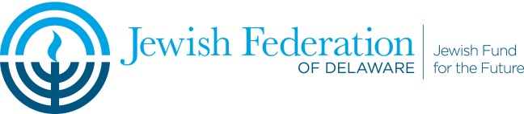

Goldinger Trust Application

The Goldinger Trust is for the purposes of “promoting and expanding agricultural research for food and fiber and animal science in Israel”

Applications should consist of no more than two pages, letter size, and should follow the headings listed below as appropriate. The review committee is looking for the potential utility of the research to Israel. The Fund will accept applications for early stage development programs.

Note for multi-year requests, an acceptable progress report must be submitted before additional funds are released.

Application deadline: October 29th
Grant distributions are anticipated to be made in December

Application Headings

Organization:
Name, Address, Primary Contact, Phone, Email.

Project: Name, Total program budget, Dollar amount requested.

Purpose:
Basic Research: Novelty and scientific basis

Potential utility of results
Development programs: Product concept – route to market.
Potential impact on the Israel economy
Related Work: If this proposed work is a component of a larger project or of a collaboration, please describe that related work, and how your proposed project fits into the larger project.

Scientific/technical status of field:
Competitive landscape
Current state of the art as it relates to your proposed project

Program Plan:
Goals
Methodology
Quantitative milestones

Resources:
Key researchers (If the proposed work will be under the supervision of or performed in collaboration with anyone but yourself, please state who that will be and his/her relationship to the project)

Facilities (Please describe what facilities and equipment you will require to perform your project, and clearly distinguish what you will have available to you from what you will need to acquire. In the latter case, state the estimated cost of that facility or equipment.)

Collaborations

Other funding (Please provide a spreadsheet showing a complete and full breakdown of estimated costs, whether you have funding beyond the $20,000 you seek herewith, if so, from what source. If you have applied for other funding but have not yet received it, please state in what amount and from whom.)

Applicants should also include a separate non-confidential project summary (no more than 200 words) that can be shown to a third party.

H:/Gina/Goldinger/2021 Goldinger Grant Application

